Bysani Lakshmi Likitha

About Me

- Mobile No : 9848731475
- Email-Id : bysanilakshmilikitha21@gmail.com
Career Objective

- Seeking a challenging position in a reputed organization where I can learn new skills and expand my Knowledge , to get an opportunity where I can make the best of my potential and contribute to the organizations growth.

Achievements

- Social service (welfare of stray animals)
- Essay writing awards

Personal Details

- Name : Bysani Lakshmi Likitha
- Father Name : Bysani Kiran Kumar
- Date Of Birth : 21-03-2023
- Place : Kurnool
- Nationality : Indian
- Address : H:No: 1/184 Upstairs, One Town, Kurnool - 518001,
Andhra Pradesh

Education

Qualification | Institution | University/  Board | Percentage | Year Of Passing
BSC Computers  (MPCS) | St. Joseph’s Degree College | Rayalaseema | 9.0 | Pursuing
Intermediate - MPC | Sri Chaitanya Jr. College | Board Of Intermediate | 893 | 2021
S.S.C | Keshava Reddy Concept School | Board Of Secondary Education | 9.0 | 2019



Computer Proficiency

- MS – EXCEL
- MS – Word
- Basics of C
- Basics of python
- Basic of JAVA

Languages
- English
- Hindi
- Telugu
Strength

- Time management
- Ability to cope up with different situations
- Good communication skills
- Dedication towards my work

Personal Interests

- Music
- Visiting Orphanage home

Declaration:

I, Bysani Lakshmi LIkitha, hereby declare that the information contained herein is true and correct to the best of my knowledge and belief.

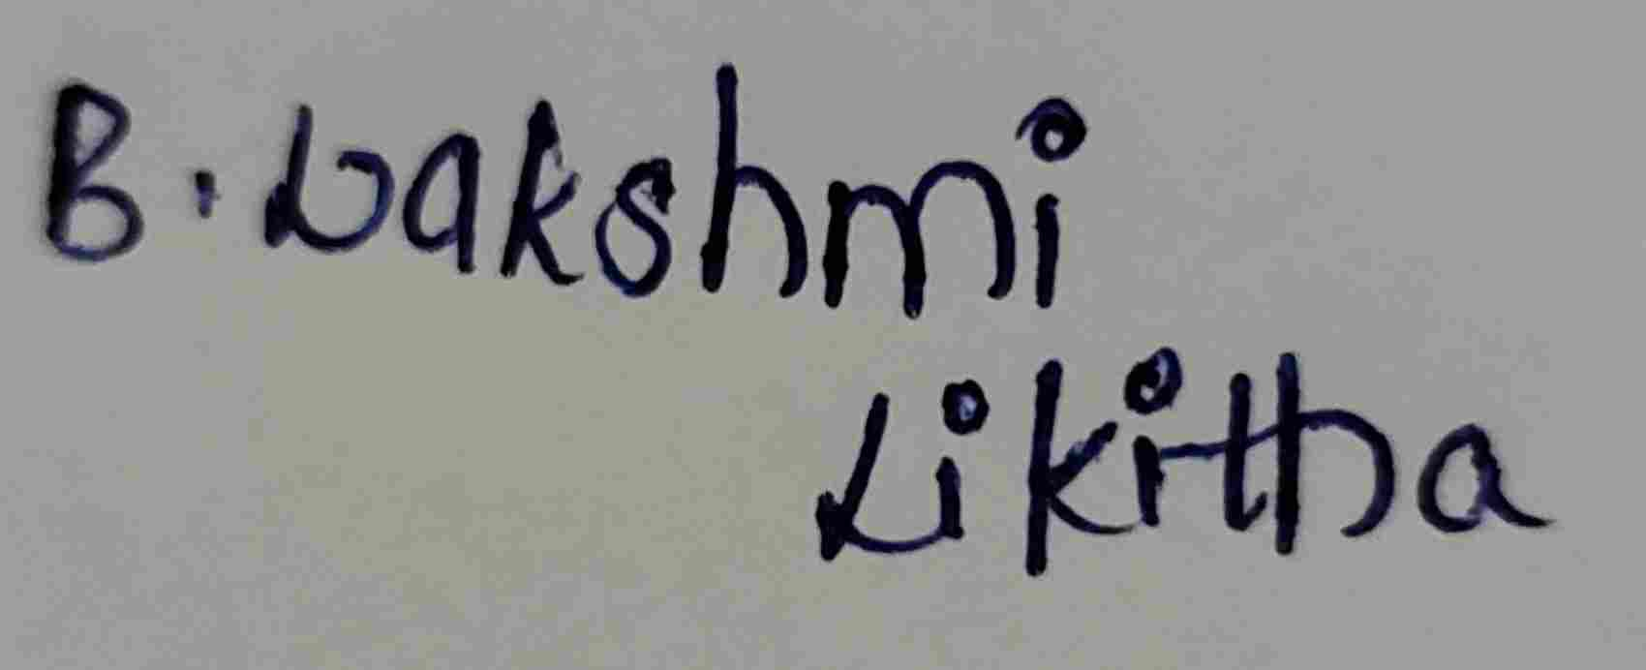
____________________________
B. Lakshmi Likitha

